Oklahoma Baptist
Disaster Relief

Water Purification
Training Manual

Updated 3.17.08
TABLE OF CONTENTS

Acknowledgement 4

Introduction 5

Unit 1
Methods of Processing Potable Water 6
Disinfection 6
Distillation 6
Sterilization 6
Micro Filtration 6
Reverse Osmosis 7

Unit 2
Southern Baptist Disaster Relief Water Purification Units:
Background and General Information 8

Unit 3
Components and Process Flow for Water Purification Units 9
Source 10
Micron Filters 12
Media Pod Filtration 13
Granular Activated Charcoal 13
KDF 55 and 85 13
Ultraviolet (UV) Light 14
Chlorination 14
Manual/Passive Chlorination 16
Automatic Chlorination 16
Chemilizer Unit 17

Unit 4
Operation of the Water Purification System During a Disaster 18
Site Location 18
Safety 18
Security 18
Water Source 19
Silt 19
Ponds 19
Wells 19
Location 20
Production of Water 20

Unit 5
Power Sources 21
Diesel Generators 21
Gasoline Generators 21
Pre-Start Check 21
Shut-Down Check 21

Unit 6
Testing 22

Unit 7
Cleaning and Storage or Continued Use 23

Unit 8
Troubleshooting Hints for 1120/240/360 Units 25
Electrical Power 25
Pump Problems 25
Ultraviolet Unit 25
Gallons per Minute Indicator 25
No Water Output 25
Chlorine Injection 26

Unit 9
Record Keeping 27
Unit Daily Report 27
Filtration Daily Log 27
Cleaning Record 27
Storage Checklist 27
Other Agency Lab Tests 27

Appendices 28
A-1 Water Filtration Unit Daily Report 29
A-2 Generator Maintenance Report 30
B-1 Water Purification Systems 1120/240/360 32
B-2 Model 830 Water Purifier 38
C-1 Metric to American Standard Conversion Tables 51
C-2 Tables for Chemilizer Stock Chlorine Solution 42
C-3 Simplified Methodology to Purify Drinking Water 43
ACKNOWLEDGEMENTS

The Southern Baptist Convention water purification program has been blessed with many godly visionaries. What started as the passion of a few has grown to a large group of volunteers from many state disaster relief ministries.

More and more water needs are being identified in third world countries. Most recently, Iraq, Iran, and Southeast Asia have benefited greatly from the Southern Baptist humanitarian response. Bam, Iran had critical needs after a large earthquake destroyed the city in 2004. Southeast Asia (Indonesia and Sri Lanka) suffered major devastation from a tsunami in 2004. The destruction from the war in Iraq has generated an enormous amount of water pollution/contaminates.

In particular, Larry Elliot had a burning vision, passion, and sense of urgency to provide clean, safe drinking water for the people in Iraq. Without concern for his own safety, he reached beyond U.S. military protection to serve those in need.

Larry is now with the Lord, looking down on us and urging those who hear God’s call to continue the work that was begun. Larry, we thank you for your passion and vision and the Godly example you provided to us.
INTRODUCTION

Safe drinking water, clean air, and nutritious food are critical issues throughout the world. These are the basic elements we need for survival. As we drink, breathe, and eat, we are using the natural elements God placed on this earth to sustain life. However, through our ignorance and materialism, we are contaminating these “pure” creations of God and jeopardizing the lives of innocent humans who unknowingly ingest harmful and even fatal “man-made” industrial and human contaminants.

The U.S. probably has the most informed knowledge of contaminations in drinking water. Although we in the U.S. have knowingly contaminated territorial water, we have researched, diagnosed, and tested purification processes to restore the U.S. water delivery system locally. However, during times of disaster, the source of purified water is often inadvertently compromised with contaminants. Third world countries, who struggle in daily life with contaminated water, face an even worse situation during a disaster.

The Southern Baptist Convention desires to supplement the spiritual “living water” provided by missionaries with “livable” drinking water. This handbook provides information on systems developed within the convention that will, in fact, purify waters that have been contaminated.

The basic process of all the purification units uses the same system/techniques. The differences in the various units will be in flow through/volume, physical size, and transportability.

Improvements in the system are ongoing. In particular, Texas Baptist Men have simplified the system by replacing the electronics with mechanical/analog meters and equipment. In addition, the process sequence of the latest units has been changed to minimize particles and contaminants on the UV quartz sleeve.

Please keep in mind that this manual is a “living document.” It is revised on a yearly basis as new technology becomes available. Also, criteria for water purification varies from country to country. If you have any questions about whether a particular unit meets criteria, or if you have any questions about the way a particular model works, please contact:

Rusty Gilbert Dick Talley Dick Jarvis
(Oklahoma Disaster Relief) (Texas Baptist Men) (Florida Baptist Men)
Cell (405) 409-6371 Cell: (214) 707-4780 Cell (407) 455-4558
Home (405) 728-0983 Home: (214) 328-1318 Home (407) 298-5670

METHODS OF PROCESSING WATER
UNIT 1

Water that is unsuitable for drinking or of questionable purity can be processed in a variety of ways to make it potable (suitable for drinking).

Disinfection

Adding a poison to the water to kill bacteria results in disinfection. Care must be taken to prevent overdose, which can harm humans and animals. Chlorine is the most common type of disinfectant used in water.

Chlorine, a greenish yellow chemical, element Cl, atomic #17, atomic weight 35.5, is found in nature combined with other elements. It was employed as a war gas during World War I. Only 40 to 60 parts per million (ppm) of chlorine in air inhaled for 30 minutes or more can cause serious injury. Chlorine should be respected, but not feared, if handled in the right way. Chlorine has been universally accepted as an excellent disinfectant by public utility authorities. Chlorine kills rather than removes bacteria. The chlorine burns the bacteria and requires a contact time to accomplish this process. Recommended chlorine injection into drinking water will range between 4 and 8 ppm, (U.S. public utility water usually has 1 to 2 ppm). Water that has been chlorinated should be allowed to sit for at least 30 minutes before being used for drinking.

Distillation

Distillation is accomplished by boiling the water until it becomes steam, then condensing the steam back to water. This process leaves a deposit of the harmful particles and minerals in the vessel used to boil the water. The vessel must be cleaned regularly to remove the deposit. The cost of heating the water is prohibitive. The most common use of this method is on ships that use engine heat to boil the water and remove the salt.

Sterilization

Ultraviolet (UV) light can provide a high level of sterilization in water. Sunlight is a natural source of ultraviolet light and provides “sterilization” as water flows down rivers, over waterfalls, through rapids, etc. When bacteria, viruses, and other microorganisms are exposed to the germicidal UV light at a particular wavelength (253.7 nanometers), their reproductive capabilities are destroyed, and they no longer pose a threat to human life. However, UV light does not provide a residual disinfectant in water, which can then be re-contaminated.

Micro Filtration

Micro filtration can purify water by using filters that are not larger than 0.2 microns. This is extremely small and usually requires high pressure. Some viruses may be able to pass through these filters.

Reverse Osmosis (RO)

Reverse osmosis (primarily for industrial use) removes salt, other minerals, bacteria, and other harmful organisms from water. However, certain bacteria and viruses may slip through the membrane. Most places that use reverse osmosis to purify water follow up with an ultraviolet treatment and/or chlorination. One third of the water in the RO process is used to back flush the system and is therefore wasted and must be discharged. RO requires energy that is not usually available. In addition, it is costly.
SOUTHERN BAPTIST DISASTER RELIEF WATER PURIFICATION UNITS:
BACKGROUND AND GENERAL INFORMATION
UNIT 2

For many years, Southern Baptist Disaster Relief (SBDR) has responded to natural and man-made crises throughout the United States and abroad. The response effort may include chainsaw removal of downed trees, mud-out of flooded homes, hot meals three times per day for thousands of people, child care, initial medical assessment (sorting the more serious injuries from the minor ones prior to EMT/medical personnel arrival), and water purification to provide pure drinking water. In most natural disasters—floods, tornadoes, hurricanes, fires, etc.—there is an urgent need for “potable” or safe drinking water.

Contaminated water can severely exacerbate a disaster situation. Prior to restoration of drinkable public water, an interim water source or resource is needed. Southern Baptist Disaster Relief has been building transportable water purification units for a number of years. These units provide pure drinking water from a rate of 120 gallons per hour up to a maximum of 1,200 gallons per hour, depending on the water unit used.

There are numerous models for water purification used by SBDR. The intent of this handbook is to provide an understanding of the “process” and stages of purification used. Once this is understood, particular attention can be directed to specific models. The main differences that will be found within the various models will be the output capacity, i.e., gallons per minute or gallons per hour. Also, of course, there will be significant differences in the shape and packaging of the different units. However, once you understand the process and the function of each component, you will be able to recognize them as they are used in all units provided by SBDR. Some older units may have manual chlorinators as compared to the automatic chlorinators in the newer and updated models.

By fully understanding the general processing stages, you will be able to set up and operate more than one specific model or type system. Each of the different types of water purifying units used by SBDR is described in this handbook.

Texas Baptist Men has designed a much simpler (less electronic hardware and displays) system, the 830 model. A number of these systems have been installed in Iraq and Iran recently. This simple standardized system allows for better logistics support, is adaptable for easy “carry on” to aircraft, and is easily packaged for entry into foreign countries. The 830 has an improved process sequence which will be discussed later in this handbook.

At the 2005 Disaster Relief Roundtable, the national water purification subcommittee and other state disaster relief representatives made the decision to “standardize” water units to the “830” configuration, include this system in all domestic feeding units and transportable kitchens, as well as all stand alone water purification systems for overseas disaster needs. Information on other SBDR water units is included in this manual since those units may continue to be used while they are in inventory until they are expended. Once these other units (1120, 240, 360) are no longer in inventory, this manual will be reduced to cover only the “830” water units.
COMPONENTS AND PROCESS FLOW FOR WATER PURIFICATION UNITS
UNIT 3

The earlier SBDR water purification units are compact, field operated units, housed in a rugged metal container. These units can operate independently on a 12 volt DC internal battery source, from an automobile electrical system, or from 115/220/240 volt AC sources. The newer standardized SBDR 830 water purifier has been simplified electronically but maintains the same water purification components of the earlier SBDR water units. The water purification components have been modularized and mounted on three to four separate plywood panels with quick connect/disconnect hoses coupling the components together. The packaging of the 830 allows easier maintenance and transportability.

The two types of systems—earlier and newer—are shown in Figures D-1 and D-2. The components of water purification for both systems are the same. However, note the separation of the media pod in the 830, i.e. the KDF (Kinetic Degradation Fluxion) pod is first in the process and then the GAC (Granular Activated Charcoal), and the two are not mixed. Also, the UV light is “after” the media (KDF and GAC) in the 830 water purification process. Finally, note the filtration/ disinfection chart (Figure D-3).

Filtration

Micro filtration (blocking) and media filtration (contact) are both used in the water purification processes described in this manual.

Blocking - The two stages of micron filtration (5 and then 1 or 0.5 micron) essentially “block” insolubles that are greater in size than the filter rating. These “insolubles” can be a combination of harmful and harmless elements. The filtration “blocking” of harmful elements provides more purity to the water output of the micron filters. And, the filtration “blocking” of the harmless insolubles eliminates the possibility of “shading” the subsequent filtration of ultraviolet light on any remaining harmful bacteria or viruses.

Contact - The media filtration (KDF/GAC) removes the contaminants by contact. Water with contaminants that pass through the media is exposed to a reaction by that media that renders contaminants harmless by a cladding and oxidation process. The media, depending on the volume/quantity, requires specific contact time with the water to allow the cladding/oxidation process to occur. Therefore, control of water flow rate through the media is essential to assure adequate contact reaction time. KDF/GAC media cartridges have specific maximum flow through rates which should be adhered to.

The Ultra Violet (Uv) light filtration is another type of “contact” filtration. The filtration occurs by a specific frequency of Uv light shining on a contaminant for a specific time. Again, the flow rate through the Uv unit is essential. All Uv lights have a specified maximum flow rate and should be adhered to.

Source
Water is drawn by a self-priming pump or if pressurized, bypasses the pump and flows on to begin the purification/filtration process. This input source of water, if coming from other than a local pressurized water system, will be subject to foreign matter that can block/clog the water pump impellor or the micron filters. Most systems have an input spin filter (80 mesh screen) that is removable for cleaning. Also, additional pre-filters should be used to remove debris if clogging is observed (Note: When water is to be drawn from a pond, lake, or stream, the hose input point should be placed 12-18 inches below the water surface.). The water flow rate will vary with each unit depending on the pump capacity, the pressure of the local water system, if used as a source, or the distance the pump must “lift” the water from the other static sources.

Water pumps for the older purification units (1120/240/360) are driven by 12 volts DC with maximum water output rates of 2, 4, and 6 GPM respectively. The 12 volt DC source is provided by either a battery or rectified 115 volts AC/240 volts AC power (these AC to DC rectifiers are designed into the water units). In foreign countries the power source voltages and frequencies are different. The voltage may vary from 220 to 240 volts AC, but the frequency is 50 cycles. Sometimes the pumps will overheat because of the power difference caused by the lower frequency and voltage. If this overheating problem exists, it may be necessary to purchase a 50 cycle water pump locally.

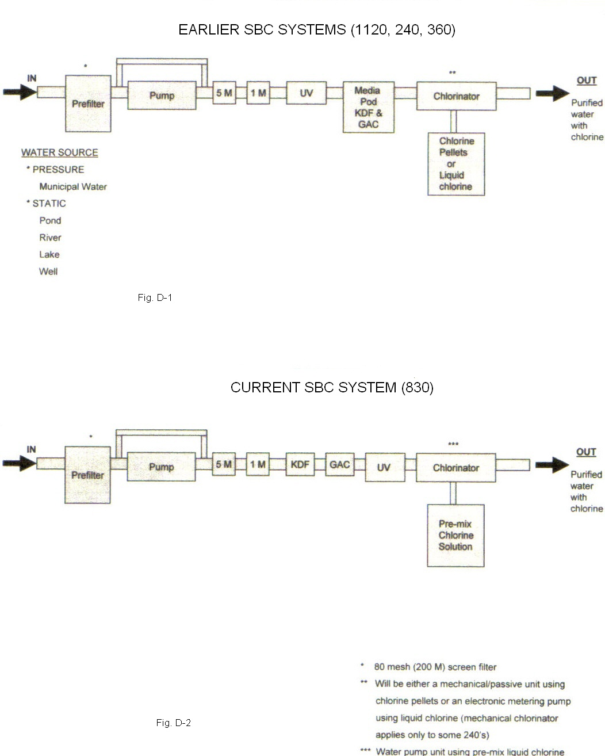

Micron Filters

The next stage of water purification process is a series or sequence of two micron filters. First, the term “micron” will be discussed to provide an understanding of the level of “filtration”. Micron is, of course, a metric term. The U.S. has not adjusted well to the notion of the metric system. Here is a simple explanation: A micron is 10 to the minus 6 meters. What does this mean? 10 to the minus 6 meters means 0.000000 meters. Continuing on, one micron is 0.000001 meters. Convert metric (meters) to the more familiar Imperial/American Standard (inches). One meter is equal to 39.37 inches. Substitute the 1 meter for 39.37 inches, resulting in a value of one micron= 0.00003937 inches. Now you can better understand the fineness of filtration of a 5 micron and 1 micron filter. Metric to American Standard conversion tables are provided in Appendix C-1.

The two micron filters, i.e., 5 micron and 1 micron, are staged to sequentially block small, microscopic, insoluble particles, some of which are protozoa and bacteria. The larger filter (5 micron) is first and blocks the larger particles, and then the second filter (1 micron) filters some of the remaining particles, protozoa, and bacteria. This micron filtration has two main purposes:

1. Filter out protozoa and some of the bacteria.
2. Filter out most of the particles in the water.

The latter filtration of particles is a very important pre-process prior to UV purifying. Particles in the water can block the ultraviolet rays from some of the bacteria.

Micro filtration blocks particles larger than the filter size, i.e., 5 microns and 1 micron. All protozoa and most bacteria are larger than 1 micron and will therefore be blocked. However, filtration will not block bacteria smaller than 1 micron and virus or E coli . Some of the contaminants the micron filters will block are:

Giardia—a protozoa often found in surface waters which have been contaminated by human sewage or by wildlife.

Cryptosporidium—contains reproductive body (spore) that is capable of developing asexually into an independent organism and propagates by spores as algae and fungi.

Bacterium (except E Coli)—any of numerous widely distributed unicellular microorganisms ranging from the harmless and beneficial to the intensely virulent and lethal.

Ultraviolet (UV) Light

Sunlight has natural UV rays. UV from the sun is used in aeration ponds by cities to help purify their water. The optimum frequency of UV light that will kill bacteria, viruses, and other microorganisms is a wavelength of 253.7 nanometers (10 to the minus nine power or 0.0000002537meters). These microorganisms must be exposed for a certain length of time in order to inactivate them and destroy their reproductive capabilities. The strength of dosage is a product of the UV light intensity and exposure time. This UV disinfection system channels water past submerged lamps that emit lethal doses of UV energy, destroying bacteria and viruses.

The UV lamp is housed in a quartz sleeve that is waterproof sealed and allows the water to pass around the UV bulb while exposing UV energy through that water. Any particles that may still be in the water would allow some bacteria or virus to be “shaded” from the UV light. Therefore, it is important to have the micron filtration prior to UV exposure.

UV dosage depends not only on the wattage or power of the UV bulb but also depends on the exposure time, i.e., flow rate of water through the unit. The UV intensity is fixed (except for slow degradation of intensity over the life of the bulb), but the water flow rate is variable. Therefore, it is important that the specified “flow rate” of water through the system is not exceeded. Water purification units will have flow rates of two gallons, four gallons, six gallons, and higher rates per minute. For product output measurement for dispensing of water needs, it may be more appropriate to use “gallons per hour”, i.e., two gallons per minute would equate to 120 gallons per hour, etc. Allow the UV lamp to warm up for about five minutes before dispensing water.

Media Pod Filtration

The media pod is a combination of two media materials that will remove organic, inorganic, and metallic contaminates, including the 17 materials on the current U.S. Environmental Protection Agency Hazardous Materials List. Note: In most of the older water purification units, the media pod combines both media material. In the newer or later units, the two media have been separated.

Granular Activated Charcoal

One of these media is GAC or Granular Activated Carbon. Activated carbon has a positive charge and absorbs or traps volatile chemical and organic compounds. Carbon also removes taste, odor, color, and chlorine. The longer water is in contact with this filter medium, the more time the carbon has to react in removing the impurities. Therefore, the effectiveness of the filter is a function of the amount or volume of carbon and the flow rate of the water through the cartridge.

KDF (Kinetic Degradation Fluxion) 55
The other media is KDF 55 Process Media. This media is a special high-purity alloy blend of zinc and copper pellets that works on the electro-chemical and spontaneous oxidation reduction (redox) principles. Water soluble cations (positively charged ions) of lead, barium, arsenic, cadmium, chromium, selenium, mercury, copper, nickel, iron as well as chlorine, heavy chloroforms, and other dissolved metals are oxidized into insoluble matter and attach to the media (chlorine is instantaneously oxidized).

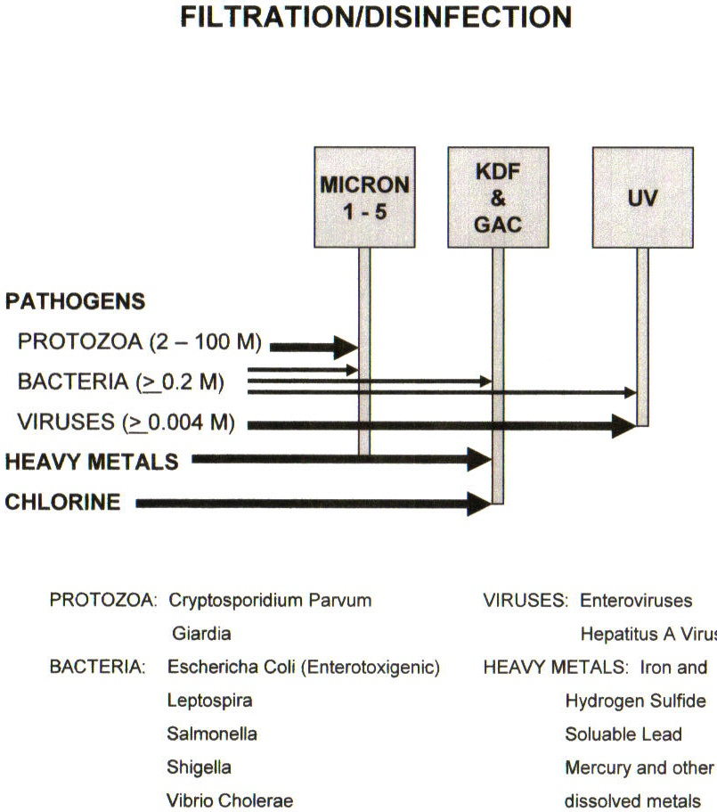

Fig. D-3

Chlorination

Chlorination is the last stage of the water purification process. Chlorine has been universally accepted as an excellent disinfectant by public utility authorities. Chlorine kills rather than removes bacteria. The chlorine burns the bacteria and requires a contact time to accomplish this process. The remaining chlorine after “burning” bacteria is called “free chlorine”. When testing the output of the water purification unit, the free chlorine and total chlorine should be the same, indicating no bacteria in the water. Commercially available water quality test strips (litmus strips) are provided with the water purification units. Follow the instructions on the bottle of test strips. Test strips should be kept in their original container, which should be kept closed before and after use. Be aware that chlorine has a shelf life (indicated on the container).

Note the following precautionary statements for chlorine:

Danger: corrosive. May cause severe irritation or damage to eyes and skin. Harmful if swallowed. Protect eyes when handling. For prolonged use, wear gloves. Wash after contact with product. Avoid breathing vapors and use only in a well ventilated area.

First aid: if in eyes: hold eye open and rinse slowly and gently with water for 15-20 minutes. Remove contact lenses, if present, after the first five minutes, then continue rinsing eye.

If swallowed: call a poison control center or doctor immediately for treatment advice. Have person sip a glassful of water if able to swallow. Do not induce vomiting unless told to do so by a poison control center or doctor. Do not give anything by mouth to an unconscious person. Call a poison control center or doctor for further treatment advice. Have the product container or label with you when calling a poison control center or doctor or going for treatment.

Clorox information line: 1-800-292-2200.

Note to physican: probable mucosal damage may contraindicate the use of gastric lavage.

Physical or chemical hazards: product contains a strong oxidizer. Always flush drains before and after use.

Do not use or mix with other household chemicals such as toilet bowl cleaners, rust removers, acids, or products containing ammonia. To do so will release hazardous, irritating gases. Prolonged contact with metal may cause pitting or discoloration.

Storage and disposal: store away from children. Reclose cap tightly after each use. Store this product upright in a cool, dry area away from direct sunlight and heat to avoid deterioration. Offer empty container for recycling. If recycling is not available, discard container in trash. Not harmful to septic and waste water treatment systems.

Although the processed water has now passed through micron filtering, UVsterilization, and the two forms of media purification and is assumed to be “drinkable” and contaminant free, the chlorination is still required. Most United States public utilities require between 1 to 2 parts per million (ppm) chlorine in the water dispensed to the public. In disaster situations, SBDR will use a higher standard of 4 to 8 ppm in order to ensure integrity of purified water. Also, once the water is purified and contained in a holding tank, the chlorine will help to keep it pure. When water is dispensed into disaster victims’ containers, there may be some contaminant in the container that will be “burned” by the residual chlorine. If chlorine is not injected at the water purifier output, before putting water into questionable containers, rinse each container with a mixture of 2 tablespoons chlorine (5.6% concentrate) per 1 gallon of water, or 1 capful of chlorine per 1 gallon of water.

Three types of chlorinators are used in the water purification units: a manual/passive unit, an automatic unit, and a “water pump” injector called a “chemilizer.” Note: Some of the older water purification units may have been updated to the newer automatic injection unit.

Manual/Passive Chlorination

This chlorinator uses pellets or bleach in a container inside the water purifier unit and has a metering knob on the front of the container. The mix of chlorine in the water will change each time the unit flow is shut off, requiring readjustments each time the unit is “turned on.” Chlorine normally used is liquid chlorine bleach such as Clorox. Also, chlorine pellets that are either the commercial (very strong) or the type used in swimming pools may be used. One of the commercial pellets will chlorinate over 5,000 gallons of water. The chlorine mixture should be pre-mixed to provide a 2.25% mixture within the chlorinator injection unit. As an example, Clorox which is 5.25% would need only a mixture of half water, half Clorox.

Automatic Chlorination

This chlorinator is an electrically controlled injection pump that requires liquid bleach or a chlorine mixture for injection. Care must be taken to not adjust the two knobs (rate/frequency and stroke/length) when power is “off.” Also, the pump should be placed out of direct sunlight to prevent overheating. And, the chlorine injection point must be higher than the top of the solution supply tank (chlorine source) to prohibit gravity feeding. Liquid Clorox, mixed with an equal amount of water, should be pumped by this automatic unit to provide the injection chlorine needed at the output of the water purification unit. Adjustments of the stroke length should initially be set at 100% (only after the unit has been activated/on) and then the rate knob adjusted to obtain the initial closure on the desired ppm for the chlorine. Allow at least two minutes for the PPM to stabilize. Caution: Water should not be dispensed until the correct amount of chlorine has been obtained and the chlorine has had at least a 30-minute “settling” in the output container.

Adjustments to both the manual/passive and automatic chlorinator injection units are made only after the water purification unit has been set up and water has been passing through the unit and has been adjusted for the required flow rate.

Chemilizer Unit

The chemilizer unit provides chlorine injection into the purified water by means of a water motor that drives a chemical pump. This pump is accurately calibrated at the factory and provides injection of a stock chlorine solution into the water flow at the rate specified on the pump label (1 ounce to 1 gallon, 2 ounces to 1 gallon, 1 to 100 (metric), or 2 to 100 (metric) ratios).

If the desired content of chlorine in the purified output water is in the range of 4 to 8 parts per million, then the chlorine solution must be mixed to a ratio consistent with the factory pre-set injection ratio. This stock solution is injected into the purified output by the Chemilizer at the factory pre-set ratio.

Normal household bleach found in most stores is now 6% chlorine. This percentage figure represents parts per hundred. This is a bleach solution at 6 parts per hundred chlorine. If one ounce of bleach is added to 100 ounces of unchlorinated water, the chlorine is diluted by a ratio of 100:1, resulting in a solution with 6 parts per ten thousand. This is right ratio (parts per ten thousand) for the Chemilizer input. To use a 5-gallon (640 ounces) container for the input solution to the Chemilizer, add 6 ounces of bleach which will result in slightly less than 6 parts chlorine per ten thousand parts water. If the Chemilizer pre-set ratio is 1:100, the resultant injection in the purified output water would be 6 parts per million (ppm) chlorine. If the pre-set ratio was 1 ounce to 1 gallon (128 ounces), the purified output water would be 4.6 ppm.

Tables for 1 ounce to 1 gallon and 1 to 100 (metric) ratios are provided in Appendix C-2: Tables for Chemilizer Stock Chlorine Solution.

OPERATION OF THE WATER PURIFICATION SYSTEM
DURING A DISASTER
UNIT 4

Disasters occur randomly, generally without warning, and result in a rapid response need. The more trained and efficient Southern Baptist Disaster Relief can be through training during the “lulls” of disaster, the better SBDR will be able to respond to the needs. Disaster needs within the continental U.S. are more readily and easily accommodated because of our familiarity with “our” customs, language, infrastructure, and resources. However, disasters in foreign countries can and usually do create additional problems that SBDR needs to work out on a case-by-case basis. The following is a general procedure or the highlights of considerations for operating a water purification unit. In no way is this a rigid, “must follow” outline.

Site Location

This is a very important decision that can sometimes create unnecessary confusion and stress. People in a disaster situation need stability. A daily routine is very important. Once water is provided at a specific area or location and at a specific time, it is important to schedule this to continue regularly at the same place and time. Therefore, make every effort to select a site that will have an abundant water source, if possible, and at a convenient location, if possible. Interruption of schedule and location of water dispensing should be minimized.

Safety

Safety of all personnel is a top priority. If the site selected for water purification is in a shelter or refugee camp, interruption of water supply could cause unsettling or anger by the general population. It is recommended that water be purified at the source and then dispensed to the public at a site where needed.

Safety from animals, snakes, etc., is also important.

Operating electrical equipment in a wet area or during rain can be hazardous.

Safety of water unit operations personnel is critical. Before removal or contact with any of the filters, be sure to put on protective prophylactic disposable gloves. Remove all the old micron filter cartridges and place them in double plastic bags for later disposal and burial. Place a reminder note on the water unit that micron filter cartridges are out and new filter cartridges must be put in before starting the unit.

Security

Security of equipment is very important. The water processing could be terminated because of lack of equipment/parts/supplies. In some countries miscommunication or misunderstanding could lead to missing tools, parts, or equipment. It is recommended that the area of work be “roped off” and entry restricted in that area. Portable generators that provide the necessary operating power could be a high value target almost anywhere during or after a disaster.

Water Source

The water source with the best probability of purifying should be selected. If negotiation with other agencies is required, the importance of this factor should be communicated. The quality of the water source determines the amount of water that can be purified and how much obstruction or restriction occurs from clogged filters. The water purification units can purify water in almost any condition, but each condition affects the amount of good water that is produced and its impact on the equipment.

Silt

Silt in the water source will cause the micron filters to clog quickly, requiring frequent replacement, which in turn requires a large supply of spare filters. Using water from a swiftly moving stream usually means that there is a lot of silt, i.e., the silt is more readily transported by the swift water flow. However, this silt concentration can be greatly reduced by digging or constructing a small pond or tank of water off to the side of the main water source. This will allow water to seep or will slow the flow, which will allow the silt to naturally “drop” to the bottom.

The pond area does not need to be large, possibly 10 feet in diameter and as deep as practical. Next, provide a channel from the main, fast flowing stream, and fill the channel with large rocks and some sand. Allow this pool to fill and settle and then place the “suction” line or pipe as near to the surface as possible. If possible, selecting a stream with cattails or reeds will provide a cleaner water source as this vegetation acts as a natural filter (Note: This does not apply to ponds with algae on the surface.).

Ponds

Many ponds have algae growth. This will plug the filters. If this is the only available water source, the algae most likely will be near the surface. You should place the suction line or pipe 12 to 18 inches below the algae but not on the bottom.

Wells

The main problem with using an existing well is that the water level may be too low. Most of the water purifying units have a 12-foot suction hose. The reason for the 12-foot length is that the pump will not pull water any higher than 12 feet. This lift problem may also be a problem at a stream or pond.

Location

The working location of the water purifier needs to be where it will not get muddy. There will be water on the ground because of spillage, etc. If a paved surface is not possible, a sandy soil would be the next level down. Lastly, if there is no alternative but in a muddy place, put the water purification unit on a wooden pallet or some large boards to keep it out of the mud. There are holes in the bottom of the water purification units to allow water to drain out. Mud can “back up” into the unit and prevent the unit from draining. This, in turn, could cause the electrical parts to get wet and short out, causing damage and safety of life issues. The site where the purified water is dispensed to the public should be away from the working (purifying) location. This will avoid crowding and disruption of the purifying process.

Production of Water

The best way to operate the water purifying units is to set up a “make tank” to store the purified water. The water units should be operated continuously, providing continuous water into the “make tank,” which also will allow the chlorine mix to stabilize. This water should be eventually placed into a tank or tanks that will allow local people to draw water from a faucet and fill their containers. The “public” available tank or tanks should be some distance from the actual water purification operation so as to prevent any interference with the water purification process operation.

POWER SOURCES
UNIT 5

The water purification units developed by Southern Baptist Disaster Relief are designed to be adaptable to most power situations. The internal working voltages for most of the systems operate on 12 volts DC. These units generally allow full operation from an internal 12 volt DC battery, 12 volts DC from a jumpered car electrical system, 115 volts AC., or 220/240 volts AC power source. Some systems need 115 volts AC or 220/240 volts AC for system operation. Within the continental U.S., when AC voltage is available, it is generally reliable in frequency (60 hertz) and amplitude (115/220/240 volts). However, in foreign countries it is recommended that local water pumps (designed for 50 hertz) be used.

Internal battery operation of the water purification unit can be sustained for a short period of time before becoming discharged beyond the point of useful service. All efforts should be made to find a reliable power source such as a portable AC voltage generator to accommodate the water purification unit. If the water need is in the continental U.S., there will usually be a “feeding unit” accompanying the disaster need. Generally, portable generators are available with these units. In the third world country situation, there may be no alternative but to use local power. Be sure to have the voltage measured prior to power hook-up to the water processing unit!

Diesel Generators

Check the oil level each time the unit is refueled and use clean, fresh fuel.

Gasoline Generators

Check the oil level each time the unit is refueled. Do not refuel the generator when it is hot.

Pre-start Check

Never assume there is adequate oil...always check the oil level first. Fill the fuel tank and be sure to wipe any spillage. Make sure all power is turned off before starting (this removes the “starting” load from the generator). After the generator engine is running, turn on the electric power switch. Observe that the engine does not “bog down” with the load on. If it does, the load demand is too large...sequentially remove some of the other non-critical loads to allow normal running of the generator engine.

Shut Down Check

Turn off the electrical power switch and allow the generator engine to idle down and run to cool the generator with no load. After shutdown, change the oil before storing the unit. Clean the unit.
TESTING
UNIT 6

Testing the water available at a disaster site is essential. For disasters within the USA, usually the municipal water system is the source of water that has been compromised in some way. In third world countries, the water system is not usually a utility distribution system but individual sources at wells, streams or ponds. These sources may have always been contaminated to a certain extent and with the advent of a local disaster are compromised even more.

When there are water needs as a result of a disaster within the USA, the following testing procedure is used by the Tennessee Southern Baptist Disaster Relief team. Pressure at the tap from a water system at the disaster location (25 psi or more) indicates the system has integrity and the water plant is pumping or that standpipes (water tower or reservoir on a hill) still have useable water. If the plant is pumping, a measurement of Turbidity (see instruments noted below) will indicate if the municipal water plant is filtering (a low Turbidity reading indicates filtration is occurring). And finally, a measure of residual chlorine (see instruments noted below) in the water of 0.50ppm or more indicates the water is o.k. to use as is. Also, an additional test of the pH of the water will indicate if any contaminants are present. (A reading of 6 to 8 is in the neutral range, less than that would be acidity and greater represents the alkalinity.) It is important that you contact the local municipal water plant to confirm your test results. As an example, if your test results reveal low chlorine levels, generally it is o.k. to add chlorine to the water and go ahead and use it. Also, if the pH test is not in the normal range, the local water utility should be able to identify the problem. The water should be checked on a regular basis for the first few days (2 or more) to ensure that the system is stable.

As a last resort, if water is not available from the municipal system or has lost integrity, there is a high turbidity in the water, low or no pressure, no chlorine, then the complete SBC water purification system should be used until municipal water becomes available (this may mean pumping from a river, lake or pond temporarily).

In third world countries, it is likely there will be high turbidity levels in the water and probably no chlorine. Also there may be high levels of bacteria and possibly heavy metals, and other contaminants. A method of field testing for all of these contaminants has not been developed within the SBC disaster relief organization. The design of the 830 water purification system has essentially a redundant purification process design, not unlike NASA’s space systems. By redundancy, or “overkill” the stages of purification are providing a type of “fail-safe”. Between the micro filtration, media absorption and ionization, UV sterilization and finally chlorination, most contaminants are removed.

Measurement instruments used:
Hach Portable Turbid meter #46500.00, readout is in direct Nut’s (nephelometric turbidity units),
Hach Pocket Colorimeter for Free and Total Chlorine, range 0.02 to 2.00 and 0.1 to 8.0,
Hach pH measurement strips

Note: Turbidity measures the scattering of light through water caused by materials in suspension or solution.
Nephelometric is the measurement of quantity or size of particles in suspension,
by means of light transmitted or reflected from such particles.
“BOIL WATER” means the municipal system is up and running but chlorine has not passed throughout the distribution system and bacteria testing has not been completed. Even with a chlorine reading at a water tap that indicates the municipal system is working, the “boil water” condition will remain on until the municipal water company completes bacteria testing on the complete system. The ability to test the tap water and then verifying it with the municipal water company will allow a 24-36 hour advantage on using the system.

CLEANING AND STORAGE OR CONTINUED USE
UNIT 7

The water unit will be used in two different disaster response situations: within the continental U.S. and in third world countries.

The first situation is in response to disasters within the continental U.S. These disasters sometimes include the need for water purification but usually last only two to three weeks maximum before the municipal water system is restored to normal operation. The water units are then removed, cleaned, packed and placed in storage until the next disaster need. In the cleaning, packing and storage, care must be taken to purge the system of all water to preclude bacteria/fungus/mold build up in the system. Drain all water from the hoses, canisters, filters, UV unit, and chlorinators/chemilizers, but leave water in the KDF canister—once wet, it should stay wet. Any GAC filters should be removed and dried out.

The newer 830 water units should be completely disconnected and dried out, including the interconnecting hoses at the input/suction, stage to stage coupling, and output hose. Canisters should be removed and purged of water.

For the l20, 240, and 360 water units housed in metal containers, the following steps are provided:

1. Shut off all power, disconnect all power cables, coil the cables, and set them aside.

2. Drain the unit by opening all of the drain valves while leaving the inlet and outlet open.

3. After fully draining, close all drain valves and the inlet and outlet valves.

4. Before removal or contact with any of the filters, be sure to put on protective prophylactic disposable gloves. Remove all the old micron filter cartridges and place them in double plastic bags for later disposal and burial. Place a reminder note on the water unit that micron filter cartridges are out and new filter cartridges need to be put in before starting the unit.

5. Empty the chlorine source container in a safe place, clean it, and then half fill it with clean water.

6, In both the manual and electrical chlorinators, it is important that all chlorine be removed. The manual chlorinators should be emptied and washed clean with fresh water. Avoid any possible residue remaining inside the water unit as serious corrosion will occur on all the metal components. The electrical chlorinator can be purged by pumping fresh water through the pump until all chloride residue is removed. Again, it is important that all chloride be removed prior to storage inside the water unit.

7. Repack all the spare parts, UV lamp spare, quartz sleeve, hoses, and electrical cables inside the unit. Make sure everything is secured to prevent damage during shipment/transit.

The second situation of water unit use is in response to a third world disaster. In this situation, the water units that are dispatched to the disaster area usually remain there permanently for continued use in purifying the drinking water. In this situation, it is very important that knowledge of life expectancy of the filters and media are known and accounted for. The micron filters and media have an expected lifetime. Usually the media (KDF and GAC) is much longer than the micron filters. However, accountability is necessary to ensure that the water unit will continue to provide disinfected drinking water. This means that volume output, i.e., gpm/gph must be monitored and recorded to know when filters must be replaced. Sometimes, the micron filters may continuously be clogged/blocked, requiring cleaning before its useful lifetime is reached.

TROUBLESHOOTING HINTS
UNIT 8

Before troubleshooting a problem, make sure everything is connected correctly and the proper power is supplied to the water purification unit.

1. Electrical Power

a. Check the voltmeters. The AC meter should read either 120 or 240 volts.
b. The DC meter should read between 12 and 16 volts. If DC reading is zero, check the power switch for the “on” position.

2. Pump Problems

a. The pump will not run. The UV switch must be “on” for the pump to run. Also, the pump has an automatic pressure switch. If the incoming water pressure is 40 psi or more, the system pump should not run.
b. The pump cycles on and off repeatedly. This is caused by too much back pressure. Either the filters need to be replaced (because of clogging and increasing back pressure) or the input or output outlet is not fully open.

3. Ultraviolet Unit

a. Ultra violet green LED is not on.
    - The UV switch may be “off.” Turn switch to “on.”
    - There may be no water flowing. The flow switch may have trash in it, preventing it from opening. Shut system down and clean the flow switch.
b. Ultraviolet green LED is on but the UV does not show the lamp is on. Shut system down and replace the UV lamp.

- Gallons per Minute Indicator

Indicator shows total gallons and not the flow rate. Press the “Sel” button of the flow meter. If there is still no flow rate indication and the total gallons does not change, shut system down and clean the flow paddlewheel assembly.

- No Water Output

The pump runs, the suction hose is in the water, but no water is coming up the hose. Check for air leaks in the hose and connections. Make sure the outlet is open and that the hose is not plugged.

6. Chlorine Injection

The chlorine pump is pumping but no liquid is moving up the injection hose. Turn the CL prime switch “on” and open the bleed valve on top of the pump until all the air bubbles are out of the suction tubing. Close the bleed valve and liquid should move through the injection tubing (turn prime switch “off”). It takes a long time to prime the chlorine pump the first time. If needed, remove the injection hose from the injection tee and hold it outside the unit to bleed off the air. Shut off the tube by holding a finger over the end while reconnecting the tubing. Wash off any chlorine on hands or inside the water purification unit.

RECORD KEEPING
UNIT 9

NAMB’s (North American Mission Board) Incident Command Center requires daily information during national disaster relief responses. The daily reports provide data that support the needs of the Red Cross, FEMA (Federal Emergency Management Agency), Salvation Army, National Guard, and Southern Baptist Disaster Relief logistics needs. The 830 version of water purification units SBDR is now building includes a water meter that provides numerical readout of the total gallons of water processed. Therefore, the daily reporting is quite simple. This information should be provided to the site "white/blue hat" on a daily basis. Record keeping on the status of water purification units (i.e., repairs, components used, cleaning, lab tests, etc.) provides valuable information to the owners of the units as far as stocking spares and replacement parts and keeping up with the status of the unit. Repeated breakdowns or parts replacements are useful indicators of the possible need for a design change or the use of a more reliable component. Samples of the unit daily report, generator maintenance log, and filtration daily log are found in Appendices A-1 through A-3.

Unit Daily Report

The unit daily report records the number of volunteers onsite and total gallons of water purified that day, among other data.

Filtration Daily Log

The daily log should report the starting total gallons, final total gallons, record of chlorine checks, and any other items of note.

Cleaning Record

Each time the unit is used, it should be cleaned and noted on a record. This provides assurance that the unit has been prepared and is ready for future use with clean filters and spare parts replacements.

Storage Checklist

A storage checklist will assure that the unit has all needed spares, components, and items available for the next disaster response.

Other Agency Lab Tests

If a local agency has a lab test performed on the water purification unit where water is being dispensed, obtain a copy of the results and add this to the daily report and provide a copy to the site lead (white hat).
APPENDICES

Appendices A-l through A-3 show samples of a water unit daily report, generator maintenance log, and a water unit packing list.

Appendices B-1 gives a combined detailed description of three older models (120,240, and 360) of water units that have been used within Southern Baptist Disaster Relief (SBDR). There may be commercial units used in some states; these commercial units are not covered by this document. Detailed descriptions of two other SBDR water units, the Global Trailer Mounted Unit and Model 1200/200 are not included in this handbook, except for the brief descriptions below. The purification process of these two units is the same as the first three models above. The 830 Model is the latest SBDR model in use today.

Model 120/20 - This unit is the smallest and most easily transportable water purification unit. This unit provides a maximum output flow rate of 2 gallons per minute or 120 gallons per hour. It was initially designed with a manual chlorinator. Details of this system are found in Appendix B-1.

Model 240/40 - This unit provides a maximum output flow rate of 4 gallons per minute or 240 gallons per hour. It was initially designed with a manual chlorinator but some of the units have been modified with the electrical automated chlorinator. Details of this system are found in Appendix B-2.

Model 360/60 - This unit provides a maximum output flow rate of 6 gallons per minute or 360 gallons per hour. The unit was designed with an electrical chlorinator. Details of this system are found in Appendix B-3.

Global Trailer Mounted Unit - This unit is trailer mounted with self-generating electrical power and provides a maximum output flow rate of 16 gallons per minute or 960 gallons per hour. This unit also has an electric automated chlorinator.

Model 1200/200 - This unit is trailer mounted with self-generating power and provides a maximum output flow of 20 gallons per minute or 1,200 gallons per hour.

Model 830 - This unit is the latest SBDR unit and has been designed for easy transportability and simplification of systems. The maximum output flow depends on the combination of water pump, filters, and UV that are used. It should be noted that this unit has been modified/changed in the water flow sequence. The system is designed to flow water through the KDF and GAC elements prior to passing through the UV light. A detailed description of this unit is found in Appendix B-4.

Appendices C-1 through C-3 provide metric to American standard conversion tables, stock chlorine mix tables, and a simplified methodology to purify drinking water.
Appendix A-1
WATER FILTRATION UNIT DAILY REPORT

Date ______________ Time _____________ Disaster ______________________

Name of Unit ___________________________________ # of Unit _______________

Location ________________________ Unit Director __________________________

Initial Meter Reading _____________________ Date ______________ Time _______

Final Meter Reading _____________________ Date ______________ Time _______

Total Gallons Filtered _________ Water Source ______________________________

Source Container ________________________________________________________

Verification of Source Container Condition ___________________________________

Disbursement of Water (locations) __________________________________________

VOLUNTEER COUNT

_____ Number of team members at start of day
_____ Number of new team member arrivals today
_____ Total number of team members onsite today
_____ Number of local community volunteers working today
_____ Total volunteers working today (add lines C and D)
_____ Number of team members who departed today
_____ Number of team members at end of day
_____ Number of team members departing tomorrow

STAFF MEETINGS AND DEBRIEFINGS (check if yes)

_____ Morning meeting and devotional
_____ Evening meeting and devotional
_____ Other meetings (list topics apparently)
Appendix A-2
GENERATOR MAINTENANCE LOG

Date | Start Time | Stop Time | Oil Check | Oil Change | Fuel Check | Fuel Fill | Air Filter | Operator

Appendix A-3 PACKING LIST

Model 360/60 Serial Number __________________________

Chlorine pump #__________________ UV Serial # ____________________________

QTY DESCRIPTION PACKED

1 Key _______

1 120 Volt AC power cord _______

1 240 Volt AC power cord _______

1 12 Volt DC power cord _______

1 12 Ft. 3/4” suction hose with camlocks _______

1 Intake adapter with valve & male camlock _______

1 Discharge adapter/valve with male garden hose connector _______

1 White garden hose _______

1 Filter wrench _______

2 cs One micron filters _______

2 cs Five micron filters _______

1 Spare ultra violet lamp _______

1 Spare quartz sleeve _______

1 Plumbing Repair Kit
1-Tube Vaseline 1-Can PVC glue
1-Chlorine test kit 1-Assortment fittings & nipples
1-Roll teflon tape _______

1 Mix Tank _______

1 Manual and reference card _______

1 Log Book and plastic case _______

Inspected by ___________________________________ Date ________________________

Appendix B-1

Water Purification Systems 1120/20, 240/40, and 360/60

Introduction

The three models discussed in this appendix are the earlier water purification units used in disaster relief by the Southern Baptist Conference (SBC). These units are all housed in metal containers to allow easy transportation in a self-contained, stand alone system. The purification process within these units is identical, the only exception being the volume or flow rate of the purified water.

General Specifications

These water purifying systems are designed for stand-alone water treatment that will receive non-potable (non-salt) water from most sources and treat it to a purity level that is safe for drinking. The systems will filter out particles and bacteria including giardia and cryptosporidium. They will also remove volatile organic solvents, chlorine, heavy metals such as lead and mercury, pesticides and herbicides.

The systems are easy to maintain. The filters can be cleaned several times and are economical to replace. The ultra violet lamp and quartz glass tube are both easy to replace also. The purified water maximum output rates for each system are as follows:
1120/20 = 2 gallons per minute, 120 gallons per hour
240/40 = 4 gallons per minute, 240 gallons per hour
360/60 = 6 gallons per minute, 360 gallons per hour

A digital meter is provided to show the flow rate and total gallons moved through the system. The GPM flow for each system must not be exceeded as this will allow unsafe water to pass through the system. When pumping water from a static source, such as a pond, the rated water flow (GPM) for each unit may not be attained due to losses caused by the distance from the water, or the height of the pump from the water.

The system is airline freight shippable without crating or special packing. The system has a sealed gel-cell lead acid battery which is certified airline shippable.

Power Supply

Each system can utilize AC, DC, or solar power. The AC power may be either 120 volt/60 cycle (USA) or 240 volt/50 cycle (overseas). Each system is supplied with three power cords: a 120 volt AC cord with a standard US AC plug; a 240 volt AC cord plug to allow for connection to a foreign plug at the local site; a cord with a red (positive) and black (negative) cable for 12 volt DC. Connect the appropriate power cord to the unit and then to the power source and the correct power will be applied to the unit. Everything inside the system operates on 12 volts DC. A transformer and rectifier circuit inside the system changes the AC voltages to 12 volts DC. A 12-volt DC power cord is also supplied. This cord may be connected to an auto battery, solar panels, or other 12 volt DC sources, supplying at least 12 amps. The ground pin on the AC plug must be connected to an “earth ground” (a wire that is connected to a metal rod driven into the ground) to prevent shock. If using the 240-volt cord, the green wire must be connected to an “earth ground.”

There are two inside lights and a panel light on the lid to allow working at night. If working from the battery, use these sparingly as they will deplete the battery charge.
Solar Panels

Solar panels may be used with these systems to provide the power source. The panels should provide 16 volts direct current with at least 12 amps. The panels may be used for battery charging only. Use a charge regulator that may be purchased with the solar panels.

Water Flow

The flow of water through the system results in multi-stage filtration. The suction port provides the water into the system either by outside pressure or by using the pump to suction from a static water source. The system is rated for a working pressure of 125 PSI and is usable on most municipal water systems without pressure reduction. When using suction, try to use the clearest water possible to extend the life of the filters.

The water enters the system first through a trash screen (80 mesh/200 microns) and then into the pump. Next it passes through a 5-micron filter, and then a 1-micron filter. After the micron filtration, the water passes through the ultra violet assembly, the “Media Pod,” through the chlorine injection unit, and then out through the discharge ports. Please note that the 1120 system does not include a “chlorine” injector. At the point of discharge (output), the filtered water can be chlorinated if required.

Bag Prefilter

A prefilter is included in the 360/60 unit. This filter may be attached to the input port to remove sediment which will result in longer life of the regular filters. The other two units, 1120 and 240, are not provided with this prefilter, but one can be used if required, to provide additional protection of the water pump impellor and filters.

Water Flow

The water source for the system can be from a municipal pressure water source or from a static water source (pond, river, etc.). The system can operate with water pressure up to 125 PSI and is usable on most municipal water sources without need for pressure reduction.

The water enters the system first through the suction port, through the 80 mesh screen filter, into the pump, through the 5 micron filter, and then the 1 micron filter. It then flows through the ultra violet assembly, through the media pod, passes through a chlorine injection point, and then out through the discharge port.

Water Pump

The water pump is a demand type 12 VDC pump. The pump will turn on when the pressure drops below 40 PSI and shut off when the pressure reaches 60 PSI. To adjust the GPM flow, use the blue handle brass valve that is under the panel, and near the discharge. The pump draws about 10 AMPS so if you are on battery operation and can process the water without the pump, the battery will last longer.

If incoming water pressure is adequate to maintain the desired GPM flow rate, the pump will not be required and may be turned “off” at the control panel. However, if the incoming water pressure cannot meet the GPM flow rate, the pump should be turned “on” at the control panel.

Filter Pods

There are two micron polyester filter pods above the ultra violet light assembly. The first filter (on the right) is a 5 micron pleated polyester filter and the second pod is a 1 micron pleated polyester filter. Most filters are color coded to indicate the size. The 5 micron has white end caps and the 1 micron has black end caps. Do not swap these two filters, as it will reduce their effectiveness. A dirty filter may be cleaned several times by washing it in water

To remove a filter: unscrew the filter pod housing from its cap and remove the filter. The large “O” ring on the pod must have a lubricant such as permatex super lube or vaseline before replacing it. Replace the filter with a new filter, insert it into the housing, and screw it back on the housing cap. Make sure the caps are aligned so the gaskets seat properly.

A filter needs to be replaced when the flow rate drops to one-half of previous flows. CAUTION: Be sure to use prophylactic gloves before touching filters.

Note: Used filters should be placed in double garbage bags before disposal.

Ultraviolet Assembly

The ultra violet (Uv) unit in both the 240 and 360 units is housed in a stainless steel chamber with a hardened quartz glass tube separating the lamp from the water. The 1120 unit has a sealed Uv and the Uv bulb and quartz sleeve cannot be removed. Each of the water systems has a maximum flow rate: 2, 4, and 6 GPM. These flow rates are the maximum water flow that will allow adequate Uv exposure time required to kill the organisms.

Do not allow flow rate to exceed GPM rate specified for the system.

Allow the Uv lamp to warm up about 5 minutes before dispensing water.

The Uv lamp has a useful life of 9,000 hours which is equivalent to 24 hours per day, 365 days of continuous operation. Even if the bulb still works, the power produced after 9,000 hours is reduced in ability to properly kill the organisms. Replace the bulb at least every full year of use. The Uv light on the 1120 unit is “sealed” with no access to replace the bulb or sleeve, and therefore the complete unit must be replaced. If the Uv light is “on,” a violet/blue light results. This light is not visible on the Uv unit of the 1120 because it is a sealed unit. On some 240 and 360 units using a “Mighty Pure” brand Uv, there is a plastic “sight port plug” which will glow with a violet blue color when power is “on”. On other Uv units, the light can be seen by looking through the electrical connection end of the unit.

Whenever the Uv lamp is replaced, the quartz sleeve should be replaced also or cleaned. When cleaning the sleeve, be sure to clean the outside of the sleeve as this is the surface the water contacts. Do not touch the Uv lamp or the sleeve with your hands. This will leave body oil on the glass and will shorten the life of the lamp or sleeve. Instead, use a cloth or paper towel to handle these components.

Media Pod

The media pod is the large tank with blue housing. The media pod removes taste, odor, and also removes organic, inorganic, and metallic contaminates such as pesticides and heavy metals. The media pod has a variable life determined by the contaminates filtered from the water.

To test the media pod, flow water through the unit that you know has at least 5 PPM of chlorine. Do not inject any chlorine. Allow water to flow for several minutes, then test the discharge water for chlorine. If chlorine is in the discharge water, the pod needs to be replaced.

Chlorine Injection

The chlorine injection system is usually a 12-volt DC powered injection pump. The 1120 models may not have a chlorine injection system. The pump uses ordinary household bleach that it injects into the water stream. If using U.S. made bleach, it will normally be at a 5.25 - 6.0% concentration. Mix it with equal parts of clean water and pour it into the plastic tank provided. This is a 2.5-gallon container. If using bleach outside of the U. S., check the label for the concentration, and if less than 4%, use it without mixing.

To remove the chlorine assembly from the unit, unscrew the wing nut holding the injection pump to its bracket. This bracket is located under the discharge port of the unit. Remove the injection pump from the bracket and hang the pump on the lip of the box on the left side. Make sure all of the tubing is untangled and not kinked. Remove the 2.5-gallon container and place it on the ground near the pump.

To start the chlorine injection, the pump must be primed. Turn on the “prime” switch on the control panel and open the bleed valve that is located on top of the pump. Allow it to pump until all of the air is removed from the clear plastic tubing that goes back into the tank. When all air is removed, turn off the “prime” switch and close the bleed valve. The mixture will then be injected into the water stream. There are two adjustments on the pump: stroke length determines how much of the chlorine mix is injected, and the rate determines how many times per minute the pump strokes. Initially, adjust the stroke knob near 100 percent and set chlorine initial parts per million (3 to 8) with the rate knob. Then fine-tuning adjustments are by the stroke knob. Do not turn the % stroke while the pump is stopped.

Allow at least two minutes for the PPM to stabilize. Until the chlorine level has stabilized, do not dispense the water into the containers. The initial chlorine level may be very high.
When finished with the operation, clean out the chlorine tank and then pour in about a gallon of clean water. Run the pump using the “prime” switch on the control panel to flush out all the chlorine from the pump and the tubing. Clean the bleed line also. Never store the system with chlorine in any part of the unit! This will corrode everything inside the unit. Always leave clean water in the pump so it will be easier to prime the next time.

DANGER: Do not mix different types or brands of chlorine. An explosion may occur!

Preparation for Storage

When finished using the system for the particular disaster or other operation, the water units must be cleaned and drained before shipment home.

There are three drain valves located on the bottom of the inside of the box. These are 1/4” gray ball valves with blue handles. The handles are turned “inline” when opened. Open all three valves and allow all the water to drain out. Two of the drain valves are near the pump. The other drain valve is under the left end of the ultra violet assembly. Leave the suction and discharge ports open while draining.

Remove the filter pods and drain the water, then replace the filters and reinstall the pods (the note below applies). Remove, drain, and clean the chlorine unit, then replace it as the instructions in that section explain.

Water will be in the Uv housing, and should be purged. Some Uv chambers have a drain plug on the bottom side, which should be loosened to drain the water. For those that do not have a drain plug, the entire water cabinet can be tipped to drain the water from the Uv chamber.

When all the water is drained, close all three of the drain valves and place the plugs in the suction and discharge ports. Close the metal doors and tighten the wing nuts. It is necessary to store the system sealed and closed to prevent contamination or damage to the media pod.

Clean the chlorine tank and purge the chlorine pump with clean water. Do not allow any chlorine or mix to remain in the unit as it will cause corrosion.

Note: Prophylactic/protective gloves should be worn when handling the used filters. Used filters should be placed in a double plastic garbage bag and sealed before disposal.

Battery Maintenance

The battery in the system is a sealed gel-cell lead acid battery. The total AMP hours available from a fully charged system is 80 AH. The battery does not require any maintenance or water. Do not open the battery.

Storing and Charging the Battery

To keep the battery fully charged while in storage, it is necessary to connect a 120 volt AC extension cord to a building power receptacle plug that is always on. There is a battery maintainer/trickle charger installed in the top lid and it is wired directly to the battery. You must plug this maintainer into the extension cord to allow it to keep the battery in the unit at the correct charge. This maintainer will not provide adequate output to operate the system. Therefore use it as a trickle charger only to maintain the battery charge while in storage. If the battery is not kept charged, not only will it not be ready for use, the battery will “sulfate” and be ruined.

Note: Polyester/protective gloves should be worn when handling the “used” filters. Used filters should be placed in a double plastic garbage bag and sealed before disposal.
Appendix B-4

DESCRIPTION OF THE MODEL 830 WATER PURIFIER

This purifier is designed to be a low-cost, batch-operated system capable of producing 400-600 gallons of safe drinking water per hour during emergencies and until the normal water supply has been restored. It is not designed to provide a long-term solution to a water problem. However, with proper care this unit should be able to produce safe water for at least a couple of years without significant cost. See photo at the end of this section to view the Model 830.

Input tank

The input tank provides the raw water source for the purification. Each different situation will determine what action must be taken with this water. In some cases this water may come from some questionable ground water source (pool, lake, shallow well, etc.) and may require pre-treatment with chlorine, while in other cases the water may contain some free chlorine and not require any pre-treatment. If the water is being pumped into the tank from a source where some trash may be in the water, that water should be filtered through the 100 micron filter sock. In the case where the water source is from a municipal water supply that might have become polluted, the sock may not be necessary.

Pump

Unfiltered water is drawn by a 1HP jet pump capable of delivering 15 GPM head pressure at 50 pounds of pressure. In installations where the input tank cannot be placed level with or above the pump, care must be given to the choice of input hose.

Filter Assembly

This assembly contains both 5-micron and 1-micron washable polyester filters, as well as 3 pressure gauges that are used for monitoring system performance. The gauges aid in determining when and which filter is becoming blocked and needs replacement.

KDF/GAC

These two components are discussed as a unit because they work together even thought their functions are somewhat different. The term “KDF” to refers to a polyester tank and the material it contains known as Kinectic Degradation Fluxion (KDF) 55 Process Medium.

KDF helps in the reduction of free chlorine as well as removing some heavy metals and aiding in reducing some microorganisms.

GAC is an acronym for granular activated carbon. Activated carbon is used to reduce chlorine, organics, color, tannin, and objectionable tastes and odors from water.

UV Light Assembly

The ultraviolet (UV) light was added to the design to take care of any viruses or organisms that make it past the micron filters, KDF and GAC.

Flow Totalizer

The flow totalizer is mounted on the UV light assembly board and is included to aid in determining the performance of the unit as well as providing a guide as to when some maintenance actions are necessary.

Output Tank

The output is considered the last part of the purifier even though it may in fact be part of an existing system. In one application, the output tank may be a holding tank where people may bring their vessels to be filled with safe drinking water, while in some other application this tank may be a holding tank from which water is distributed throughout a hospital.

The following page shows a picture of the 830 model installed in a feeding unit.
MODEL 830

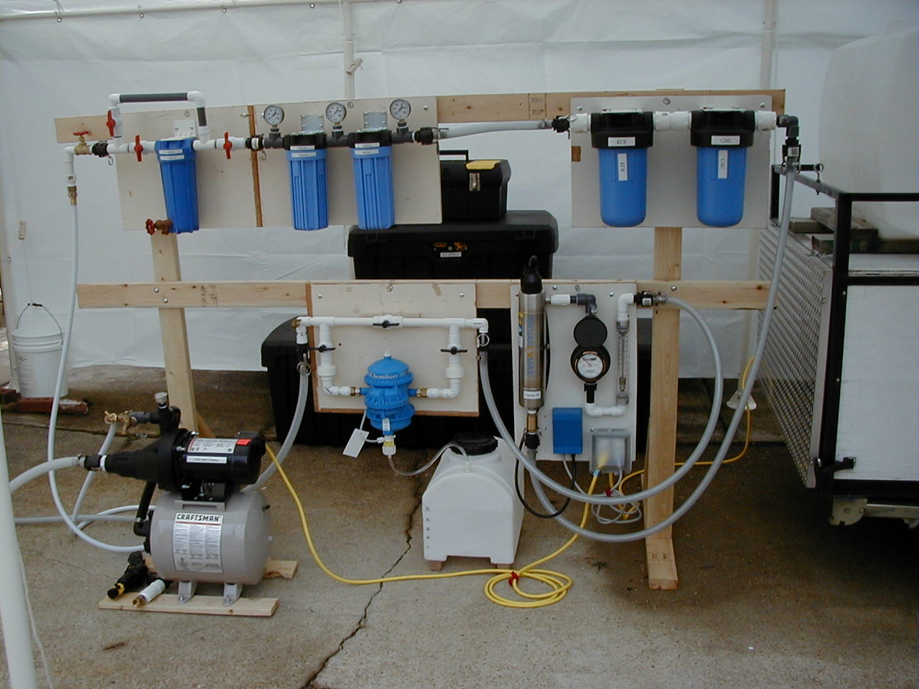

1 2 3 4 5

6 7 8 9

10 11

Components of the 830

1 50 Micron Pre-Filter (optional)
2 5 Micron Filter
3 1 Micron Filter
4 KDF Media
5 GAC Media
6 Chemilizer
7 UV Purifier Unit
8 Totalizer
9 Flow Meter
10 Transfer Pump
11 Chlorine Mix Tank
Appendix C-1

CONVERSION TABLES

Metric length and American Standard

1 meter = 39.37 inches
0.1 meter = 3.937 inches
0.01 meter = 0.3937 inches
0.001 meter = 0.03937 inches
0.0001 meter = 0.003937 inches
0.00001 meter = 0.0003937 inches
1 micron = 0.000001 meter = 0.00003937 inches
5 microns = 0.000005 meter = 0.0001985 inches

Metric system (volume)

1 liter = 1.05 quarts = 33.6 ounces
0.1 liter = 3.36 ounces
0.01 liter = 0.336 ounces

Mesh-Micron equivalency

80 mesh = 200 Microns
120 mesh = 130 Microns
140 mesh = 115 Microns
200 mesh = 75 Microns
Appendix C-2

TABLE FOR CHEMILIZER STOCK CHLORINE SOLUTION

1 quart = 32 ounces (oz)
1 gallon = 128 ounces
5 gallons = 640 ounces

Stock Chlorine Solution for 1:100 ratio

Mix five gallons of water with:

1.0 ounce of 6% chlorine to get 0.9 ppm in final output
2.25 ounce of 6% chlorine to get 2.0 ppm in final output
4.5 ounce of 6% chlorine to get 4.1 ppm in final output
9.0 ounce of 6% chlorine to get 8.3 ppm in final output

Stock Chlorine Solution for one ounce to one gallon (128 ounces) = 1:128 ratio

Mix 5 gallons of water with:

1.0 ounce of 6% chlorine to get 0.7 ppm in final output
1.5 ounce of 6% chlorine to get 1.0 ppm in final output
3.0 ounce of 6% chlorine to get 2.1 ppm in final output
7.0 ounce of 6% chlorine to get 5.1 ppm in final output
13 ounce of 6% chlorine to get 9.5 ppm in final output
Appendix C-3

SIMPLIFIED METHOD for PURIFY DRINKING WATER

Boiling Method

Boiling is the preferred way to purify water. Bring water to a rolling boil for 3-5 minutes, keeping in mind that some water will evaporate. Let the water cool before drinking.

Boiled water will taste better if you put oxygen back into it by pouring the water back and forth between two clean containers. This will also improve the taste of stored water.
Bleach Method

When boiling water is not possible, filter water, letting particles settle out. Pour off clean water. Add regular household liquid bleach (5.25 to 6% sodium hypochlorite, such as Clorox bleach not scented or color-safe) as follows:

- 4 drops regular liquid bleach per quart of water
- 16 drops regular liquid bleach per gallon of water
- 1 teaspoon regular liquid bleach per 5 gallons of water
- Mix well. Wait 30 minutes. Water should have a slight bleach odor. If not, repeat and wait 15 more minutes.

